- Docker Nginx Deployment on AWS EC2 — Step-by-Step Documentation
1. Objective
The objective of this task is to:
  - Launch an Ubuntu EC2 instance on AWS.
  - Connect to the EC2 instance using EC2 Instance Connect.
  - Install/use Docker on the EC2 instance.
  - Pull the Nginx Docker image.
  - Create and run an Nginx container.
  - Expose Nginx on port 80.
  - Access the Nginx web server through the EC2 public IP address.

2. Architecture
The setup looks like this:
Internet
|
|
Public IP: 16.171.5.18
|
| Port 80
|
+------------------+
| AWS EC2 |
| Ubuntu Server |
| |
| Docker |
| | |
| v |
| Nginx Container |
| :80 |
+------------------+

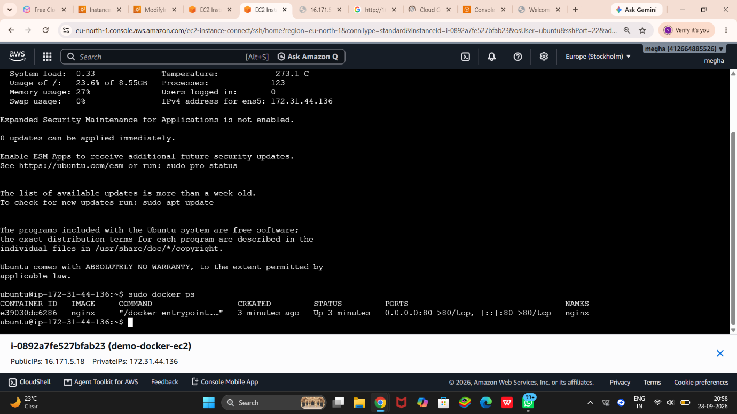 |
v
Nginx Welcome Page

3. Create an AWS EC2 Instance
First, create an EC2 instance from the AWS Management Console.
Steps
  - Open the AWS Management Console.
  - Go to EC2.
  - Select Launch Instance.
  - Give the instance a name, for example:
demo-docker-ec2
  - Select an Ubuntu AMI.
  - Select an appropriate instance type.
  - Configure the key pair as required.
  - Configure the network/security group.
  - Allow the required inbound traffic.
For this project, HTTP traffic must be allowed:
Type: HTTP
Protocol: TCP
Port: 80
Source: 0.0.0.0/0
  - Launch the instance.

4. Verify the EC2 Instance
After launching the instance, open the EC2 instance details.
Your screenshot shows:
Instance ID: i-0892a7fe527bfab23
Instance Name: demo-docker-ec2

Public IP: 16.171.5.18
Private IP: 172.31.44.136
The public IP is important because it allows you to access the web server from your computer.

5. Connect to the EC2 Instance
In your second screenshot, you are connected to the EC2 instance using EC2 Instance Connect.
The terminal shows:
ubuntu@ip-172-31-44-136:~$
This confirms that you are logged into the Ubuntu EC2 server.
Steps
  - Open AWS EC2.
  - Select your instance.
  - Click Connect.
  - Select EC2 Instance Connect.
  - Click Connect.
  - A browser-based terminal will open.
You should see a prompt similar to:
ubuntu@ip-172-31-44-136:~$

6. Check Docker Installation
Before creating the container, check whether Docker is installed.
Run:
docker --version
You can also run:
sudo docker --version
If Docker is installed, you should get output similar to:
Docker version xx.x.x

7. Download the Nginx Docker Image
Use the following command:
sudo docker pull nginx
This downloads the official Nginx image from Docker Hub.
You can verify the image using:
sudo docker images
You should see something similar to:
REPOSITORY TAG IMAGE ID CREATED SIZE
nginx latest ... ... ...

8. Create and Run the Nginx Container
Now create an Nginx container.
Run:
sudo docker run -d --name nginx -p 80:80 nginx
Explanation
The command is:
sudo docker run -d --name nginx -p 80:80 nginx
Each part has a purpose:
Command | Meaning
sudo | Run the command with administrator privileges
docker run | Create and start a container
-d | Run the container in detached/background mode
--name nginx | Give the container the name nginx
-p 80:80 | Map EC2 port 80 to container port 80
nginx | Use the Nginx Docker image
The important part is:
-p 80:80
This means:
EC2 Host Port 80 ---> Container Port 80

9. Verify the Running Container
Now run:
sudo docker ps
Your screenshot shows exactly this step.
You have:
CONTAINER ID IMAGE COMMAND CREATED
e39030dc6286 nginx "/docker-entrypoint..." 3 minutes ago

STATUS
Up 3 minutes

PORTS
0.0.0.0:80->80/tcp
[::]:80->80/tcp

NAMES
nginx
This confirms that the Nginx container is running.
Important information from the output
IMAGE
nginx
The container is using the Nginx image.
STATUS
Up 3 minutes
The container is currently running.
PORTS
0.0.0.0:80->80/tcp
Port 80 on the EC2 host is connected to port 80 inside the Nginx container.
NAMES
nginx
The container has been given the name nginx.

10. Access Nginx from the Browser
Now open a new browser tab.
Enter the EC2 public IP:
http://16.171.5.18
You should see:
Welcome to nginx!
Your first screenshot shows this page.
This confirms that the deployment is working.

11. Understanding What Happened
When you entered:
http://16.171.5.18
the request followed this path:
Your Browser
|
| HTTP request
| Port 80
v
Public IP: 16.171.5.18
|
v
AWS EC2 Instance
|
| Port 80
v
Docker
|
| Port mapping 80:80
v
Nginx Container
|
v
Nginx Web Server
|
v
"Welcome to nginx!"

12. Verify the Container Again
You can check the container whenever you want using:
sudo docker ps
To see all containers, including stopped containers:
sudo docker ps -a

13. Check Nginx Container Logs
You can view the Nginx logs using:
sudo docker logs nginx
This is useful for troubleshooting.
For example, if someone accesses:
http://16.171.5.18
you may see HTTP requests in the container logs.

14. Stop the Nginx Container
If you want to stop the container:
sudo docker stop nginx
Check:
sudo docker ps
The container should no longer appear among running containers.

15. Start the Container Again
To start the existing container:
sudo docker start nginx
Then verify:
sudo docker ps

16. Remove the Container
If you want to completely remove the container:
sudo docker stop nginx
sudo docker rm nginx
Then verify:
sudo docker ps -a

17. Useful Docker Commands
Keep this table in your documentation.
Command | Purpose
docker --version | Check Docker version
docker pull nginx | Download Nginx image
docker images | List Docker images
docker run | Create and start a container
docker ps | Show running containers
docker ps -a | Show all containers
docker stop nginx | Stop Nginx container
docker start nginx | Start Nginx container
docker restart nginx | Restart Nginx
docker logs nginx | View Nginx container logs
docker rm nginx | Delete the container

18. Screenshots to Include in Your Document
For a proper project report, I recommend arranging your screenshots in this order.
Screenshot 1 — EC2 Instance
Show:
Instance: demo-docker-ec2
Public IP: 16.171.5.18
Private IP: 172.31.44.136
Caption:
Figure 1: AWS EC2 Ubuntu instance created for Docker deployment.

Screenshot 2 — EC2 Instance Connect
Show the terminal:
ubuntu@ip-172-31-44-136:~$
Caption:
Figure 2: Connected to the Ubuntu EC2 instance using EC2 Instance Connect.

Screenshot 3 — Docker Container
Show:
sudo docker ps
and the output:
IMAGE nginx
STATUS Up
PORTS 0.0.0.0:80->80/tcp
NAMES nginx
Caption:
Figure 3: Nginx Docker container running on the EC2 instance.

Screenshot 4 — Nginx Web Page
Show:
http://16.171.5.18
with:
Welcome to nginx!
Caption:
Figure 4: Nginx web server successfully accessed through the EC2 public IP address.

19. Final Result
The deployment was successfully completed.
The final environment is:
AWS EC2
|
+-- Ubuntu
|
+-- Docker
|
+-- Nginx Container
|
+-- Port 80
|
v
Web Browser
|
v
Welcome to nginx!
Final verification
The following command confirms that the container 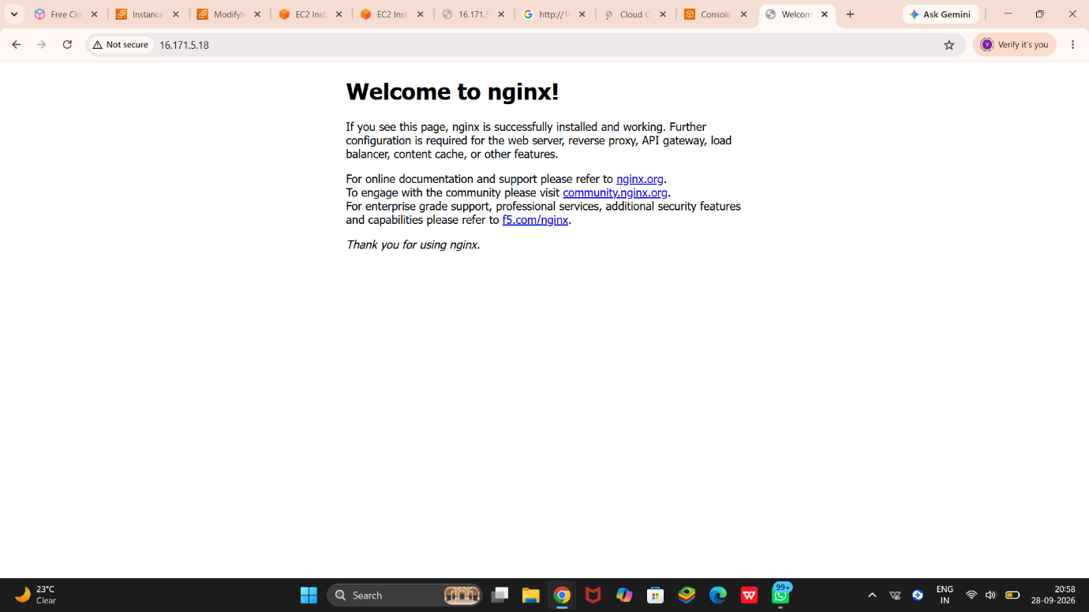is running:

sudo docker ps
And opening:
http://16.171.5.18
displays the Nginx welcome page.
Conclusion: An Nginx web server has been successfully deployed inside a Docker container running on an AWS EC2 Ubuntu instance.
Log in for personalized, step-by-step guidance.
Log inSign up for free

